Logbook Week 9
March 17, 2026

On the ninth week we:
- Finally imported the connectors and fasteners to the CAD after figuring out what we need. For connectors, we are going to use 2020 cube connectors and 2020 corner connectors because we’re going to use mostly 2020 bars, but we can find the 4040 versions if we use 4040 bars. For fasteners, we plan to use M8 bolts with corresponding nuts to fasten bars to the table, which we figured out was an M8 threaded hole, and M4 bolts with corresponding nuts to fasten bars to each other, as that is what is compatible for them based on our measurements of the bars we already have.
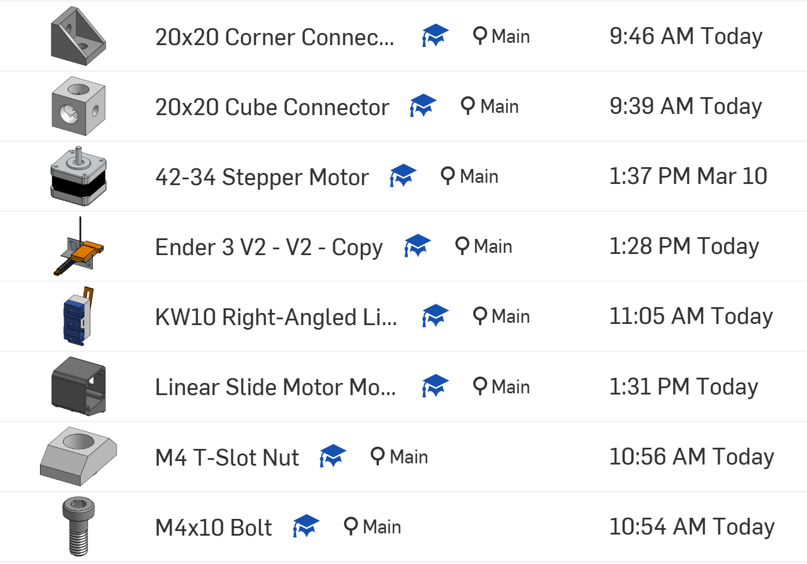
- We went shopping for limit switches. We need a bunch of them for the linear slide to stop the platform. The 3D printer we are taking parts from does have its own ones, but they don’t fit the specs that we want, so we shopped for these roller ones from AliExpress:
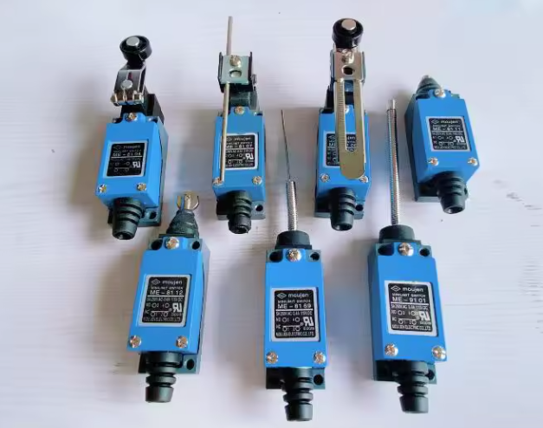

- Unfortunately the 1m extrusion bar didn’t come in time for us to assemble it in today’s session (it came to my house right after the session), but at least we have it and we can definitely assemble the linear slide next session, now that we have all the parts. We just need to design the platform and 3D print it now:
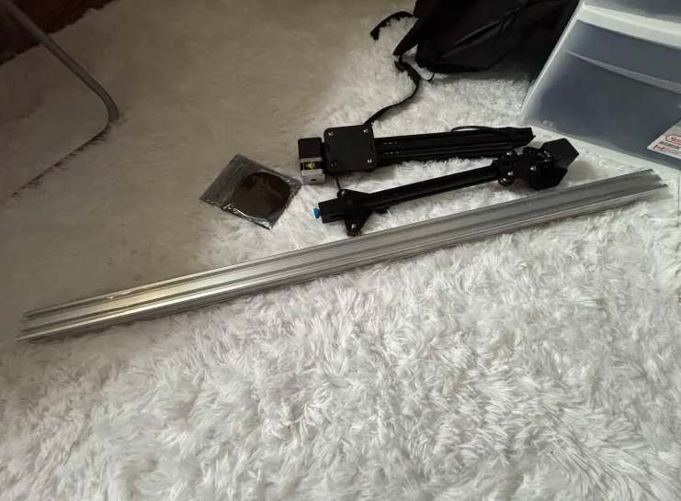
- We researched food-grade materials. We thought of nylon, stainless steel, or acrylic plastic.
- We redesigned the width between rollers and tested it with rice again. The sheet of rice comes out better than before, as an actual clean sheet, but it still has a problem that it sticks to the rollers. We are thinking of adding a string to our design that will shave the rice off the rollers so it doesn’t stick. We are still deciding what material this string will be, how we’re going to mount it, and if it’s an idea worth implementing.

Things we will work on next week:
- Figure out how we’re going to mount the limit switches and where we’re going to mount them. I’m going to work on the CAD to space things out and see how these switches are going to be placed along the main linear rail for each substation.
- Design the platform for the linear slide on CAD. Add a nib to it that will hit the limit switches as it passes through the slide. Add the necessary holes for bolting it to the roller wheels and for adding the ribcage roller platform that will rest on top of it. 3D print it. Assemble it.
- Design the CAD for the ribcage roller.

